Internal review charge questions - November 2017

AOP Information
- AOP title: Chronic Cyp2E1 Activation Leading to Liver Cancer
- Author: Carole Yauk, Francina Webster
- Associated wiki page: https://aopwiki.org/aops/220

Reviewers
Primary Reviewer (PR): Name: Dan Villeneuve; OECD Country/Org.: United States; Email: Villeneuve.Dan@epa.gov
Secondary reviewer 1 (SR1) Name: Stefan Scholz; OECD Country/Org.: Germany;
Email: stefan.scholz@ufz.de
Secondary reviewer 2 (SR2) Name: Currie Richard; OECD Country/Org.: BIAC;
Email: richard.currie@syngenta.com

Date review completed:

Review

Section 1:

AOP identifier/Title
Does the name of the AOP follow the right convention (MIE or first KE leading to AO)?

Does the name of the AOP reflect its content/domain?

Reviewers' responses and comments

PR:

SR1: -

SR2:

Author response:

Section 2:

Authors
Is it clear who the authors/developers of the AOP are?

Contact information for one or more corresponding author(s) should be included.

Reviewers' responses and comments

PR:

SR1: -

SR2:

Author response:

Section 3:

Date of updating

Reviewer should indicate the date stamp on the PDF snapshot under review.

Reviewers' responses and comments

PR:

SR1:

SR2:

Author response:

Section 4:

Abstract

Does the abstract concisely describe the main content of the AOP?

Reviewers' responses and comments

PR:

SR1: Graphical representations (p22): It is not explained, why some lines are dotted. Dot they reflect indirect relationships?-

SR2:

Author response:

Section 5:

Molecular Initiating Event
Is a MIE described? If yes, then:
Is the MIE description clear and is it biologically plausible?
Is the MIE described in a way that allows its use in other AOPs?
Are measurement/prediction methods specified and adequately described/referenced?
Is the biological context (inc. taxonomic applicability/relevance, level of biological organisation) specified and explained sufficiently?

Have chemical initiators (prototypical chemicals or chemical features) been identified?

Reviewers' responses and comments

PR:

SR1: A closer look at the description reveals that two MIEs are described. 1) Formation of reactive metabolites by CYP2E and 2) Generation of ROS by CYP2E uncoupling. In the description of these MIEs it could be pointed out that CYP2E is expressed particularly in the liver and that activation is required or has an impact on the quantitative manifestation of the MIE. It should be highlighted what activation means, i.e. stabilization of CYP2E leading to a higher level of protein abundance. What does not become clear from the description is whether the stabilization is really essential or whether constitutive levels of CYP2E would also lead to generation of reactive metabolites and ROS, but potentially at a lower level.

SR2:

Author response:

Key Events
Are the KE descriptions clear on how the events work and are they biologically plausible?
Are the KEs described in a way that allows their reuse in other AOPs?
Are measurement methods specified and adequately described/referenced?
Is the biological context (inc. taxonomic applicability/relevance, level of biological organisation) specified and explained sufficiently?

Reviewers' responses and comments

PR:

SR1:
KEs:
Both the formation of ROS and KEs trigger various parallel KE. All of them may finally lead to liver cancer, but probably the joint activation is increasing the likelihood that cancer is developed. However, in the AOP only “Oxidative stress” is mentioned as a KE. I think in compatibility to other AOPs that describe development of cancer or cytotoxicity it might be a good idea to replace oxidative stress by different AOPs or to define oxidative stress more precisely. What is actually described as oxidative stress KE may be replaced by three independent or parallel KEs:
- lipid peroxidation
- glutathione peroxidation
- DNA mutation
Lipid peroxidation and glutathione peroxidation would lead to the cytotoxicity KE, subsequently the proliferation KE and finally the AO liver cancer.
DNA mutation could lead directly to the AO liver cancer but the parallel increase in proliferation would greatly enhance the proliferation.

Role of signaling pathways:
The role of signaling pathways and pathway-specific upregulation of transcription factors may outreach the role of only a biomarker associated with a certain KE. It may indeed represent a KE itself. For instance it is stated that “…NRF2 is required for hepatocellular carcinoma precursor cells (HcPC) to progress to become hepatocellular carcinoma cells; in fact, without NRF2 excess ROS accumulate and kill the HcPC cells.” This rather resembles an essential KE than a biomarker. The same applies for NF kappa signaling pathway. However, it potentially requires more data to decide whether these event represent a real KE, but it should be at least indicated in the description of the KE that there may be more KEs or that one KE could reflect a chain of KEs.

Species specificity (page 3):
It is indicated that CYP2E1 is present at least in mammals. What about other mammals, such as fish. Could it be briefly outlined if there is any evidence that CYP2E1 could activate chemicals or lead to ROS also in non-mammals (or if a different CYP is providing this function)? On page 7 it is mentioned that zebrafish shows liver regeneration as well. Hence, at least partially the AOP is conserved across species/vertebrates.

Page 23: “…example, acetaminophen is a Cyp2E1 substrate that does not cause cancer.” This indicates that CYP2E1 activation per se may not lead to liver tumors. It is required that a chemical is metabolized by the cytochrome P450. This could be reflected by changing the MIE name(s) appropriately. See figure below in the section on AO.

SR2:

Author response:

Adverse Outcome
Is an AO described? If yes, then:
Is the AO description clear and is it biologically plausible?
Is the AO described in a way that allows its use in other AOPs?
Are measurement methods specified and adequately described/referenced?
Is the biological context (inc. taxonomic applicability/relevance, level of biological organisation) specified and explained sufficiently?
Has the regulatory relevance of the AO been described?

Reviewers' responses and comments

PR:

SR1: Suggestion for modified AO
Based on the comments above (see section on MIE and KE), I propose to change the AOP as given in the graph below:
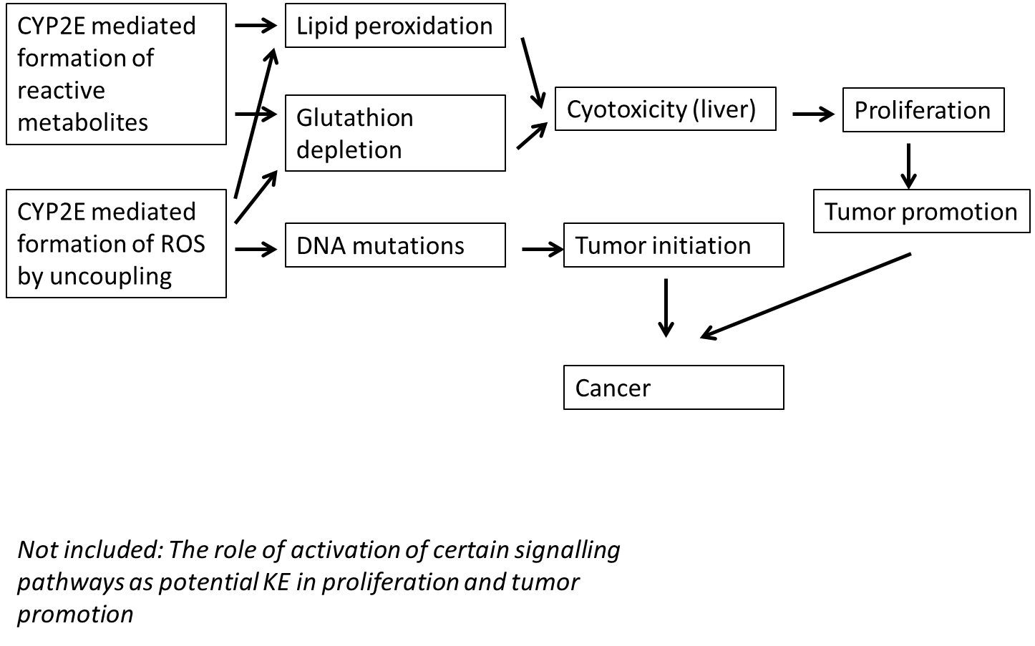

SR2:

Author response:

Section 6:

Key Event Relationships
Are the KERs well described and in a way that allows their use in other AOPs?
Are the KERs biologically plausible and is there sufficient evidence presented?
Is the level of empirical support adequately described in accordance with the OECD AOP Handbook?
Are inconsistencies, uncertainties and level of confidence adequately described?
Is the quantitative understanding of the KER described?"

[refer to Tables 2 & 3 in the handbook]

Reviewers' responses and comments

PR:

SR1: -

SR2:

Author response:

Section 7:
Overall Assessment of the AOP
Is the domain of applicability of the AOP defined appropriately?
Is the level of support for essentiality of the KEs adequately described and assessed?
Has the degree of quantitative understanding of KERs been assessed properly?
Has consideration been given to the overall weight of evidence for the AOP?
Are the calls on Overall WoE and Quantitative Understanding supported?

Reviewers' responses and comments

PR:

SR1: See general observations and conclusions below

SR2:

Author response:

Section 8:
Potential application of the AOP (optional):
Is any context provided as regards the reason for development or the intended use?

Reviewers' responses and comments

PR:

SR1:

SR2:

Author response:

General Observations and Conclusions of the Reviewer

Reviewers' responses and comments

PR:

SR1: The relation of the activation and subsequent KE to the final adverse effects is well described, concise and supported by appropriate evidence from the scientific literature. Based on this description a simple and straight forward AOP chain was developed. However, if the AOP description is carefully read, it becomes evident that the provided AOP is highly branched, involves at least two MIE and various KEs, partially branched or parallel, but finally conflated at the AO. Hence, it requires discussion, whether the provided AOP does indeed not reflect several and/or partially branched AOPs.
Furthermore, it requires discussion whether the activation of CYP2E does represent the MIE instead of reactivity to lipids or DNA. And the CYP2E activation would rather represent a toxicokinetic constraint that drives and explains the specificity to liver. Indeed, one may argue that if an organism is exposed to the reactive metabolite directly, this would also trigger the KE – but probably not in a liver-specific manner. A potential solution to describe the AOP could be to use a different terminology for the MIE(s) with focus on the formation of reactive metabolites.

SR2:

Author response:

