Figure 1. Induction of DNA adducts in genomic DNA isolated from germ cells in mice treated with ENU (10-250 mg/kg) via intraperitoneally (i.p.) injection. Adduct formation was determined using high-performance liquid chromatography at 2 hours. Figure created using data retrieved from van Zeeland et al. (1990).

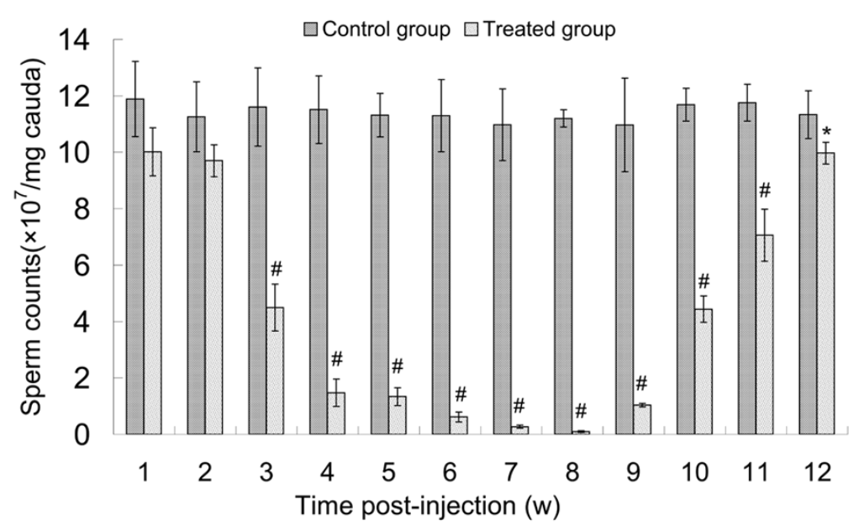
Figure 2. Sperm counts in the cauda epididymis of control and mice treated with 100 mg/kg/week of ENU for three weeks. *p<0.05 and #p<0.01 vs. control group. Figure replicated and adapted from Yin et al. (2014).

