Relationship: 2074
Increase, DNA strand breaks leads to Increase, Apoptosis

Figures

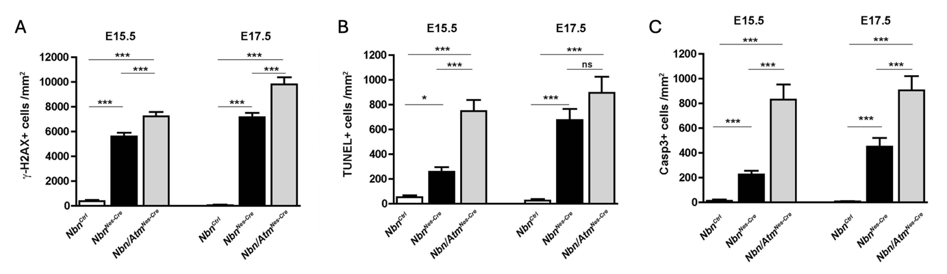
Figure 1. Quantification of DNA damage and apoptosis markers in developing mouse cerebellum at E15.5 and E17.5. (A) Percentage of cells with γH2AX foci, indicating DSBs; (B) Percentage of TUNEL-positive cells, representing apoptotic DNA fragmentation; (C) Percentage of cleaved caspase-3-positive cells, indicating apoptotic activation. Data are shown for control (Nbn^{Ctrl}), Nbn-deficient (Nbn^{Nes-Cre}), and Nbn/Atm double-deficient (Nbn/Atm^{Nes-Cre}) mice. Error bars represent SEM; statistical significance is indicated as *p < 0.05, **p < 0.01, ***p < 0.001, ns = not significant. Figure recreated from Rodrigues et al. (2013).

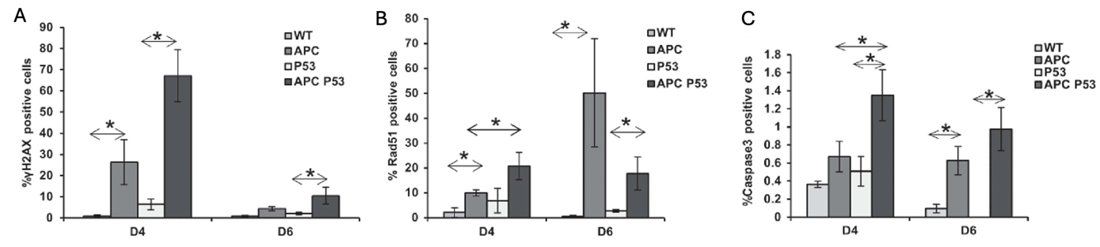
Figure 2. P53 deficiency enhances DNA damage, DNA repair, and apoptosis induced by Apc loss. Percentages of (A) γH2AX-positive cells, (B) Rad51-positive cells, and (C) caspase-3-positive cells in at day 4 or day 6 in wildtype (WT), Apc-deficient, p53-deficient, or Apc/p53 double knockout mouse hepatocytes. Figures from Méniel et al. (2015).

Figure 3. Relationship between loperamide concentration (μM), the percentage of DNA in the comet tail (% tail DNA) and % apoptotic cells in the Molt4 acute lymphocytic leukemia cell line. The % tail DNA was measured using the alkaline comet assay to quantify loperamide-induced strand breaks. The % apoptotic cells were quantified using the Annexin V/7AAD+ and flow cytometry. Figure created using data retrieved from He et al. (2018).
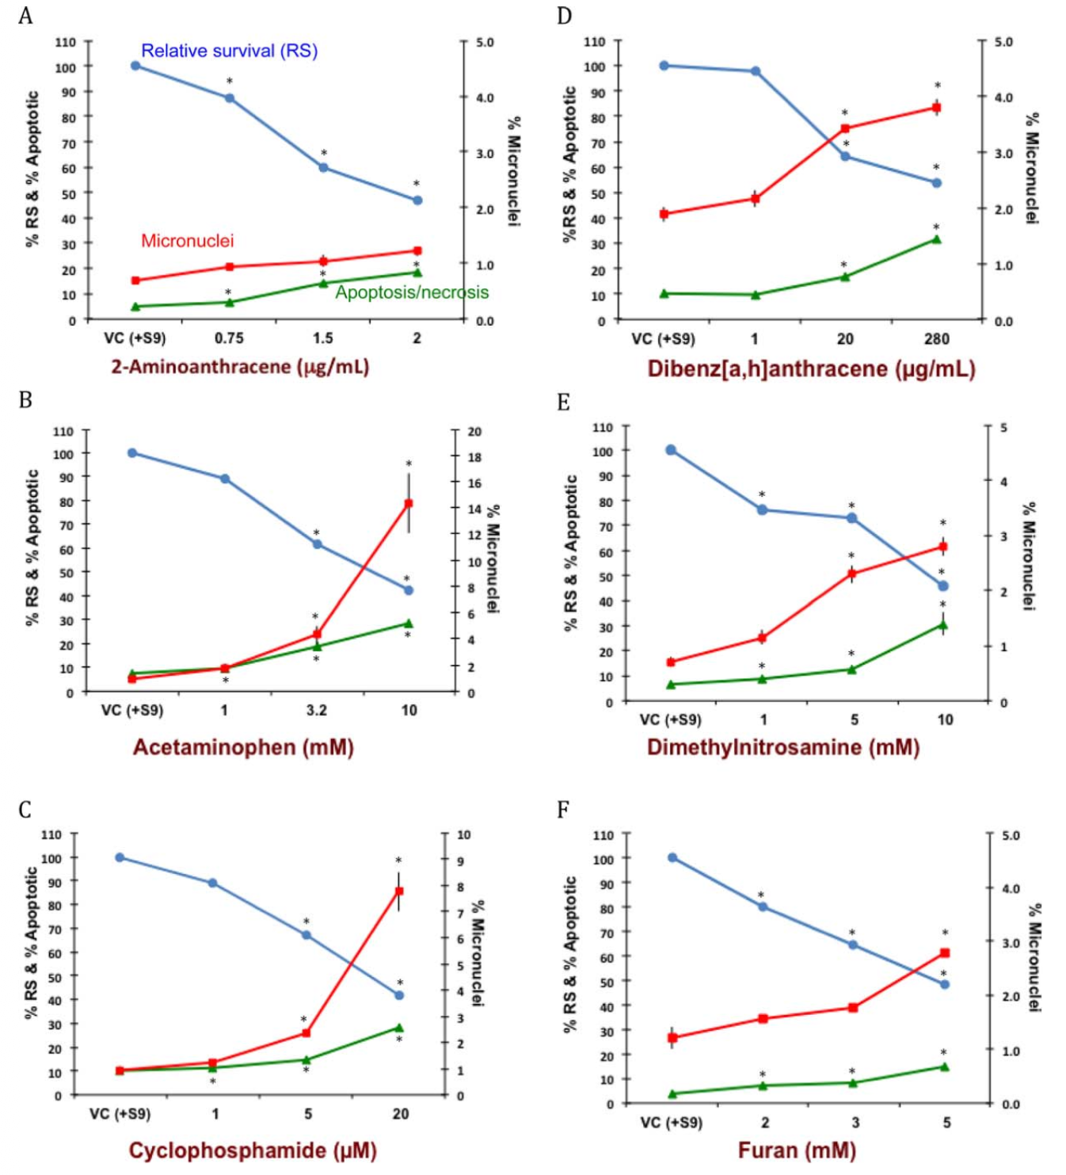
Figure 4. Relative survival (% RS – • – left axis, blue), apoptosis (% apoptotic – ▲ – left axis, green) and MN frequency (% micronuclei – ▪ – right axis, red) in human TK6 cells (n = 3) following exposure to various concentrations of six genotoxic agents. Figure replicated from Yauk et al. (2016).

Figure 5. Relationship between DNA strand breaks and apoptosis in rodent spermatogonia and spermatocytes. The % tail DNA and % apoptotic cells in spermatogonia (left column) and spermatocytes (right column) were quantified in adult male NMRI mice (A-B) or Sprague-Dawley rats (C-F) following exposure to 50-1000 μM Dox (A-B), ENU (C-D), or MNU (E-F). DNA strand breaks were assessed using the alkaline comet assay, and apoptosis was quantified using the TUNEL assay. Figure created using data retrieved from Habas et al. (2017).

