Comments for Authors on September 17, 2026
C10-#2 AOP networks on ROS induced growth inhibition

Authors: You Song, Li Xie, Knut Erik Tollefsen

Coach: Shihori Tanabe

----------
Comments for Authors + Authors’ responses

C10-#2 AOP networks on ROS induced growth inhibition

Authors: You Song, Li Xie, Knut Erik Tollefsen

Coach: Shihori Tanabe

July 31st 2026

Authors’ responses submitted on Oct 6, 2026
Coach’s comment on Oct 20, 2026
Coach’s comment on Oct 22, 2026

1. The title can be accorded with OECD guidance.
Authors’ response: Agreed. We have added the direction of change for the MIE and changed the titles of the six AOP to:
AOP 324: Increase in reactive oxygen species leading to growth inhibition via oxidative DNA damage and cell cycle disruption
AOP325: Increase in reactive oxygen species leading to growth inhibition via oxidative DNA damage and cell death
AOP326: Increase in reactive oxygen species leading to growth inhibition via lipid peroxidation and decreased cell proliferation
AOP331: Increase in reactive oxygen species leading to growth inhibition via lipid peroxidation and cell death
AOP332: Increase in reactive oxygen species leading to growth inhibition via protein oxidation and decreased cell proliferation
AOP333: Increase in reactive oxygen species leading to growth inhibition via protein oxidation and cell death
Coach’s comment: Okay.

2. Regulatory relevance of the AO can be revised with point of view of early life stages.
Authors’ response: We revised the "Considerations for Potential Applications of the AOP" section of all six AOP main pages (AOP 324, 325, 326, 331, 332 and 333) to address early life stages explicitly. The changes are:
- Sensitivity of early life stages. Each page now states that embryonic, larval and juvenile stages are expected to be particularly sensitive to the pathway, and that the AOP is especially relevant for interpreting growth effects in early-life-stage tests. The rationale is specific to each pathway. For AOP 324 it is the high growth and proliferation rates. For AOP 325 it is the dependence of growth on viable cell populations during development. For AOP 326, 331, 332 and 333 it is the dependence on sustained ATP supply, plus viable cell populations (AOP 331, 333) or high proliferation rates (AOP 332).
- Regulatory relevance of the AO. Each page now notes that reduced early-life-stage growth can compromise survival, development and reproductive success. These are outcomes of demographic significance for population sustainability, which strengthens the regulatory relevance of the AO in line with the Handbook (Section 2J).
- Assays and test systems. We added that NAM and cytotoxicity assays based on embryonic cells or embryo models can be mapped to the AOPs. In AOP 324 and 325 we also specified the relevant early-life-stage context for growth tests, such as TG 210.
- Weight of evidence and research needs. Life stage was added to the weight-of-evidence considerations (AOP 326, 331, 333), and early life stages were added to the method-development and future-research needs (all six AOPs).
Coach’s comment: It does not seem that the “Considerations for Potential Applications of the AOP” sections in the AOP top pages have been changed in the AOP-Wiki.
Coach’s comment: Okay.

3. The level of support for Essentiality of the KEs can be revised to clarify the description of AO (in terms of AOP263) in the table.
Authors’ response: As AO is the final event and does not have a downstream KE, the essentiality assessment (which by definition assesses the impact of upstream KE as the main target) of the AO is considered not needed. But the evidence support for the AO was assessed in terms of biological plausibility and empirical support sections. Therefore no change was made.
Coach’s comment: Okay.

4. MIE1115 Increase in ROS is cellular and KE1392 Increase in Oxidative Stress is molecular. Some rational starting with cellular event leading to molecular event may be added.
Authors’ response: After a discussion with the coach, we have agreed that this should be further discussed in the Mystery of ROS group, as both levels of organization are ok, but context-dependent. Therefore we did not make any change.
Coach’s comment: Okay.

5. KE155 is defined as "cellular" event, however, "cell" term is not defined.
Authors’ response: We have however added the general cell and organ terms to the KE page.
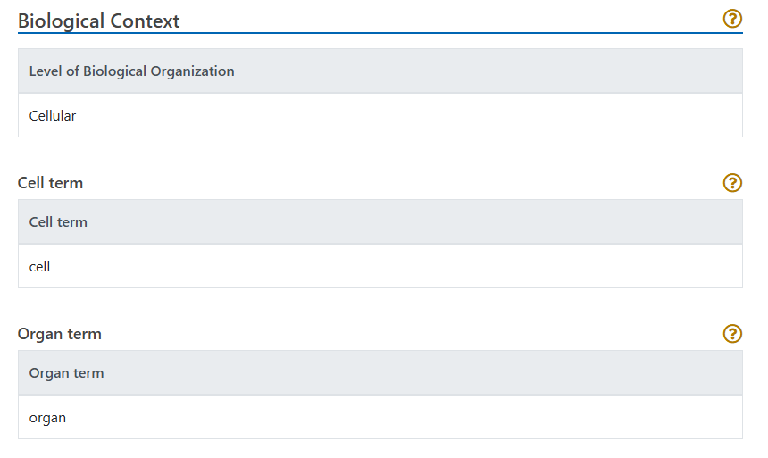
Coach’s comment: Okay.

6. The life stage applicability domain is early life stages such as embryo and juvenile in current AO (KE1521) Decrease, Growth. How It is Measured or Detected can be updated with measurements.
Authors’ response: Agreed. We have added the following text to this section (marked with non-endorsed:
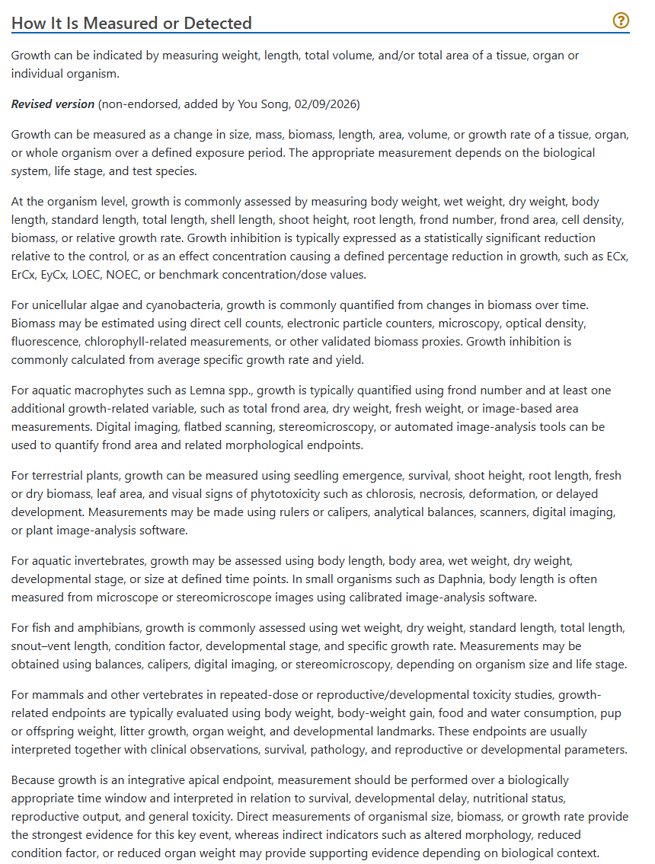
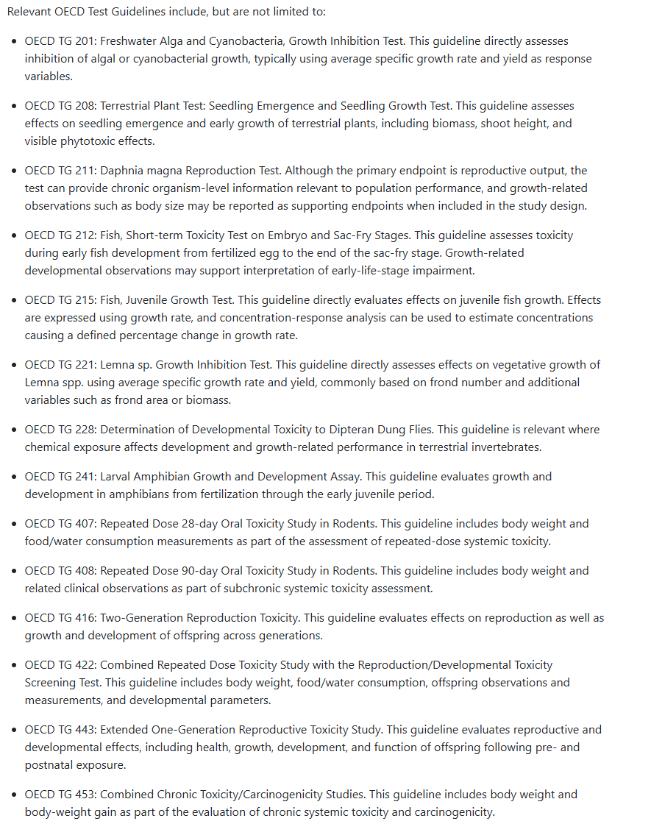

Coach’s comment: Okay.

7. Taxonomic Applicability “mouse” and “rat” in KER2009 “Increase, ROS leads to Increase, Oxidative Stress” was added by authors of different AOP and deleted by the authors of AOP324. Has the author of AOP505 been informed? The rational for deleting “mouse” and “rat” can be explained. In text of Domain of Applicability, it is described as “The current AOP-Wiki relationship page identifies human, mouse and rat with high evidence, but the ROS-growth evidence base supports extension to algae, fish, crustaceans, mollusks and other organisms relevant to environmental toxicology (AOP-Wiki, 2026a). The relationship is expected to be conserved because it is based on redox chemistry and conserved antioxidant-defense systems rather than on a taxon-specific receptor or signaling pathway.” as of July 31st 2026.
Authors’ response: This was a mistake and we have added mouse and rat back to the domain of applicability.
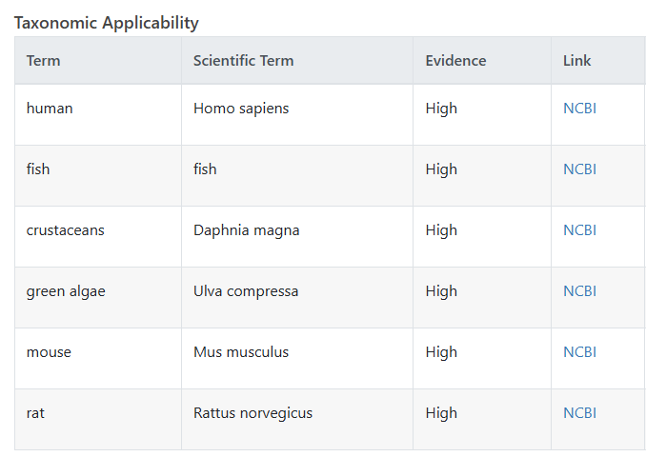
Coach’s comment: Okay.

8. Please revise KER3480, KER2203, KER2204 and KER2205.
(Revision points are highlighted with markers in the excel file.)
Authors’ response: We have added text the missing sections on these KER pages.
Coach’s comment: Okay.

